[](https://www.google.co.uk/url?sa=i&rct=j&q=&esrc=s&source=images&cd=&cad=rja&uact=8&ved=2ahUKEwio8vzMkuPfAhUKx4UKHYqFClAQjRx6BAgBEAU&url=https://hhs.hugoschools.com/22560_2&psig=AOvVaw26dgIndGIMUJpDQqOXlNkA&ust=1547207314743964)

**FARM**

**News**

OCTOBER 2019

**Calf Scour**

The winter housing season is always when we see an increase in the incidence of calf scour. Both dairy and beef herds can find this challenging to manage at this time of year when housing is in constant use allowing pathogens to build up. Three of the commonest causes of scour in calves aged under 3 weeks are E. coli, rotavirus and coronavirus, all of which can result in rapid dehydration and death. As always prevention is far better than cure and there are several actions you can take to protect your calves:

● Ensure that calving areas and housing used by young calves are regularly cleaned out and kept well bedded.

● be certain that every calf has received sufficient colostrum within 4 hours of birth. Even suckled beef calves frequently fail to achieve adequate passive transfer of antibodies through unsupervised suckling. If you are in any doubt about whether a calf has suckled then make sure it has- either by helping it to suckle, bottle feeding or tube feeding.

● Vaccination of your cows with Rotavec Corona between 3 and 12 weeks prior to calving will allow them to raise antibodies against E. coli, rotavirus and coronavirus. These are then transferred to the calf via colostrum enhancing its immunity and reducing the severity of any diarrhoea. The vaccine is completely reliant on calves receiving sufficient colostrum after birth and can be a life-saver.

[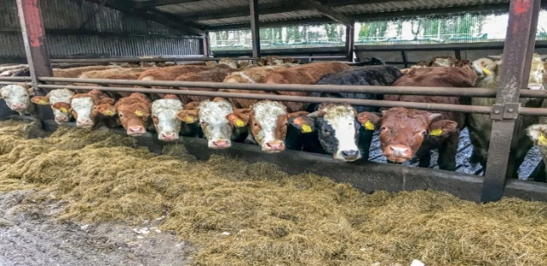](http://www.google.co.uk/url?sa=i&rct=j&q=&esrc=s&source=images&cd=&ved=2ahUKEwixj8XVy_3kAhWjD2MBHZ22AGEQjRx6BAgBEAQ&url=http://www.medpartnership.com/index.php/how-did-the-beef-sector-actually-fare-out-in-2018/&psig=AOvVaw0EHGRk__aAMUU45mz30pX6&ust=1570106134480932)

**Pneumonia Update**

This month we’ve seen several cases of pneumonia in Animals ranging from neonatal calves right through to Finishing animals. Whilst the costs involved in treating these animals are obvious, what isn’t always as easy to appreciate is the other costs involved- reduction in daily live weight gain, increase in labour and reduced feed conversion efficiency. In many outbreaks these mean that the true costs are actually 2-3 times higher

than the obvious costs. With this in mind, prevention is critical and having an appropriate vaccination strategy in place can form the backbone of this. Before embarking on a vaccination programme there are several points to consider:

● **What age of animals are you aiming to protect?**

Different vaccines are appropriate for different ages of calves, with intra-nasal vaccines being the best option for very young calves less than three months old.

● **What are the high risk times for your animals?**

For dairy calves this is often the first 6-8 weeks of life, whilst for suckled calves it is housing and weaning. Ensuring that animals have completed their vaccination course before the high risk

period is key to success.

**Lameness in Sheep**

The infectious causes of lameness, scald, foot-rot and Contagious Ovine Digital Dermatitis (CODD), make up the majority of cases but non-infectious causes such as shelly hoof, white line disease/abscesses and toe granulomas can also be important. Lameness higher up the leg are generally individual issues e.g. elbow arthritis in breeding tups. Correct identification of the cause of lameness is important as treatment varies between the various conditions. The AHDB has a quick reference guide to appropriate treatments which can be found here: [http://beefandlamb.ahdb.org.uk/wp-content/uploads/2015/06/BRP-Lameness-fi ve-point-plan-110615.pdf](http://beefandlamb.ahdb.org.uk/wp-content/uploads/2015/06/BRP-Lameness-fi%20ve-point-plan-110615.pdf)



11 Church Street, Ballygawley, Co Tyrone. BT70 2HA

Tel: 028 85567150 Fax: 028 855 67130

19 The Diamond, Pomeroy, Co Tyrone, BT70 2QU

Tel: 028 877 59358